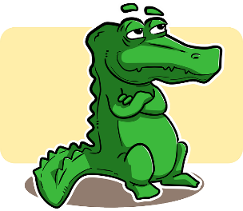
Alligator or Crocodile?

Looking at the clues, can you figure out if the mystery animal is an alligator, a crocodile, or neither? Be careful! Some of the clues apply to both, so you can write both in the blank space.

- This animal loves cold climates and lives in the north! _____________
- This reptile has a smaller head and a rounded nose. _____________
- This reptile can be found in Florida! ____________
- This animal likes to live near salty seawater or the coast. _____________
- This animal’s bottom teeth don’t stick out even when its mouth is closed.
_____________
- This animal is naturally pink. ______________
- This reptile has a larger head and a nose shaped like a V! ____________
- The fourth bottom tooth of this reptile sticks out even when its mouth is
closed. ______________
- This animal likes to live near freshwater, like lakes and rivers. __________
- This animal can be dangerous, and if I see it I should tell an adult. ________
Alligator or Crocodile?
Answer Sheet
Looking at the clues, can you figure out if the mystery animal is an alligator, a crocodile, or neither? Be careful! Some of the clues apply to both, so you can write both in the blank space.

- This animal loves cold climates and lives in the north! Neither
- This reptile has a smaller head and a rounded nose. Alligator
- This reptile can be found in Florida! Both
- This animal likes to live near salty seawater or the coast. Crocodile
- This animal’s bottom teeth don’t stick out even when its mouth is closed. Alligator
- This animal is naturally pink. Neither
- This reptile has a larger head and a nose shaped like a V! Crocodile
- The fourth bottom tooth of this reptile sticks out even when its mouth is closed. Crocodile
- This animal likes to live near freshwater, like lakes and rivers. Alligator
- This animal can be dangerous, and if I see it I should tell an adult. Both

